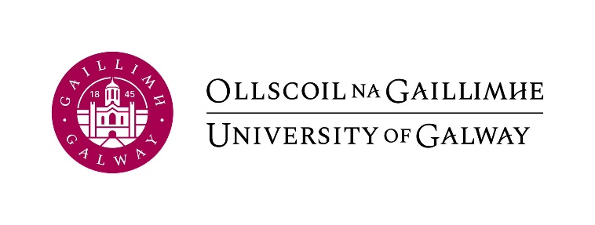


Living amidst conflict and insecurity
Workshop Program

University of Galway
18th May 2023
CA117, Aras Cairnes

10am-10.30am: Registration and welcome

10.30am-11.45am: Panel 1 – Gender, race, and sexualities in peace and conflict

Chair: Niall Ó Dochartaigh

Papers:
Caitríona Dowd (DCU) – Gendered dimensions of hunger in peacebuilding

Marianna Espinos Blasco (Ulster University) – Seeing gender and race in peace and security: The politics of (in)visibility in the Women, Peace and Security agenda

Yuliang Lu (UCD) – Peace and conflict in a queer colour: A case study of how Chinese NGOs fight anti-LGBT violence

11.45am-12.00pm: Break

12pm-1.30pm: Panel 2: Avenues to peace and justice

Chair: Sarah Jenkins

Papers:
Dana Guy (UCD) – From the battlefield to the battle on the feed: How do Israelis use social media to construct, communicate and engage with alternative narratives about the conflict with the Palestinians?

Kelsey Rhude (University of Galway) – Alternative approaches to post-conflict peace and justice: Analysing the interconnections between local justice, peacebuilding and reconciliation in post-conflict Liberia

Niall Ó Dochartaigh (University of Galway) – Back-channel negotiations in the Northern Ireland Conflict

1.30pm – 2.15pm: Lunch

2.15-3.45pm: Panel 3: Everyday peace and conflict: representations and practices

Chair: Caitríona Dowd

Papers:
Dave Banks (UCD) – Integrated team sport and intergroup relations in a post-conflict society: The case of club rugby in Northern Ireland

Sarah Jenkins (University of Galway) – Everyday peace and democracy: Navigating violent elections and ethnic politics in Kenya

Michael Breslin (UCD) – Feud violence in Ireland and Northern Ireland: A sociological analysis

Maria Guilia Molinaro Vitale (UCD) – Responsibilities of contemporary representations of war: Merlau-Ponty, Sontag, and Hollywood

3.45pm-4pm: Break

4pm-5.30pm: Keynote and round table: Everyday peace

Roger Mac Ginty (Durham University): Everyday peace

6.15pm – Book Launch: Deniable Contact: Back-channel negotiation in Northern Ireland by Niall Ó Dochartaigh. Charlie Byrne’s Bookshop, Middle Street, Galway.

Organised by the Power, Conflict and Ideologies Research Cluster of the School of Political Science and Sociology, University of Galway, with the support of the Political Studies Association of Ireland Specialist Group on Peace and Conflict.

Contact: Dr Sarah Jenkins, sarah.jenkins@universityofgalway.ie

